KAKINADA INSTITUTE OF ENGINEERING & TECHNOLOGY (KIET GROUP)
Pregnant Women Antenatal Follow-Up System
――――――――――――――――――――――――――――――――――――――――――――
Week 1 Solution Architecture Document: From Problem to Architecture
――――――――――――――――――――――――――――――――――――――――――――
C4GT Hub | C4GT – Team 1
Davuluri Bala Veera Venkata Bhavani Sankar (Team Lead)
Kolamuri Bhavya Sri | Mallipudi Satya Krupa
Bolisetti Jyothi Swarupa | Siri Bhuvaneswari
Panasa Rajini | Dasari Naveen Kumar
Mamidala Govind | Sabbisetty Anjana Lakshmi Asritha
Project Mentor: G. Sai Varshitha | IT / Industry Mentor: L. Krishna Deepika Mam
October 2026
Team Contributions & Scope Ownership
Document Section & Scope | Assigned Contributor
Problem Statement, Context & Project Constraints | Davuluri Bala Veera Venkata Bhavani Sankar (Team Lead)
Assumptions, Unresolved Questions & System Boundary | Mamidala Govind & Bolisetti Jyothi Swarupa
Actors, Use Cases, Functional & Quality Requirements | Sabbisetty Anjana Lakshmi Asritha
Component Architecture, Hero Diagram & Data Flows | Mallipudi Satya Krupa
Beneficiary Identity Design, Aadhaar Vault & Ownership | Siri Bhuvaneswari
Detailed User Flows, Sequence & Offline Synchronization | Panasa Rajini
Edge Cases, Failure Scenarios & Test Strategy | Dasari Naveen Kumar
Design Decisions, Self-Review & Out-of-Scope Roadmap | Kolamuri Bhavya Sri

Contents
1. Overview 3
The design in brief 3
2. Problem Statement and Assumptions 4
2.1 The problem 4
2.2 Example scenario 4
2.3 Intended users 5
2.4 Architectural constraints 5
2.5 Assumptions 5
2.6 Unresolved questions 6
3. Actors and Use Cases 7
3.1 Actors 7
3.2 Key use cases 7
3.3 Role-based access control 9
4. Functional Requirements 9
5. System Boundary 10
Inside and outside the system 10
6. Component Architecture 11
6.1 Architectural principles 11
6.2 Architecture diagram 11
6.3 Component responsibilities 12
7. Data Flow 13
7.1 How data moves through the system 13
7.2 Data flow catalogue 14
7.3 Domain events 15
8. Detailed User Flow: Record an Antenatal Assessment 16
8.1 Scenario and starting conditions 16
8.2 The Flow at a Glance 16
8.3 Step-by-step explanation 17
8.4 Registration with duplicate check 19
8.5 Offline entry and batch synchronisation 20
9. Limitations 22
9.1 Limitations of the current design 22
9.2 Deferred items and future dependencies 22
10. Self-Review 23
Review against the assignment questions 23

1. Overview
This document describes the architecture of a proposed antenatal follow-up system for NGO field workers who support pregnant women in rural and tribal communities. It is a design document: nothing described here has been built or deployed. It is written so that a developer who was not part of the team discussions can understand what the system must do, who uses it, how it is built and how data moves through it.
In one sentence: the system keeps a shared digital file for every pregnant woman an NGO supports. A Field Worker registers her, records each antenatal assessment and sees her full history. The system reminds the team what is due and highlights the risk signs that the worker observed. It records and organises information only; it never diagnoses a condition or decides medical care.
Core safety boundary: the system organises information. It never diagnoses or decides treatment.
Figure 1 gives a one-page view of the problem, users, workflows, components, data entities, quality attributes and out-of-scope items. The sections that follow explain each part in turn.
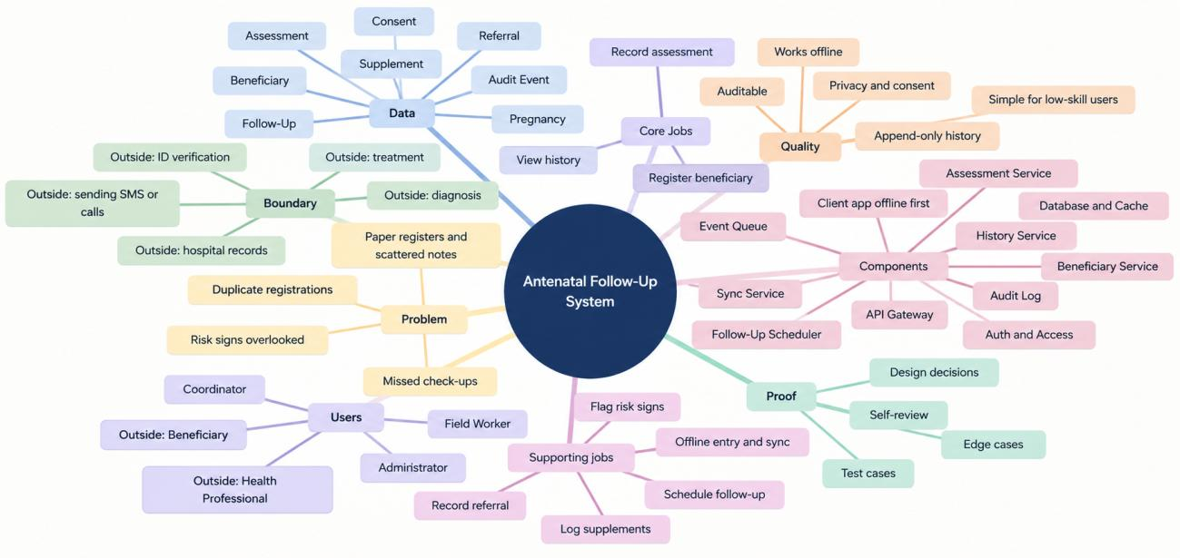
Figure 1: System overview - problem, actors, workflows, components, data, quality attributes and boundaries

The design in brief
- Three user roles. Field Workers record data daily, Coordinators monitor overdue and flagged cases, and Administrators manage accounts and schedules. Health professionals and the pregnant woman are outside the digital boundary.
- Three core workflows. Register beneficiaries, record assessments, and view a complete history in date order.
- Two supporting operations. Schedule and track due and overdue follow-ups, and work offline with background synchronisation.
- Checks at the perimeter. Every external request passes through an API Gateway that validates the token and role before any business component runs.
- One identity per woman. Duplicate detection runs on the device and on the server to prevent fragmented records across villages.
- Append-only clinical history. Assessments, supplement logs and referrals are dated events. Past records are never overwritten.
- Flag, never diagnose. Observed risk signs are highlighted for coordinator review. Diagnosis and treatment stay with qualified people.

2. Problem Statement and Assumptions

2.1 The problem
Many pregnant women in low-income, tribal and rural communities do not receive regular antenatal care. Complications such as gestational hypertension, severe anaemia and incorrect foetal position often go unnoticed until they become emergencies. NGOs and community health missions send field workers to identify pregnant women, screen them at home, track supplement use and guide high-risk mothers to health facilities. When this information is kept in paper registers, spreadsheets and notebooks, the following problems occur:
- Scattered records. Demographics, measurements and visit notes sit in separate places, so there is no complete health picture.
- History is hard to reconstruct. A worker in a remote village cannot verify earlier readings or whether iron-folic acid (IFA) supplements were taken.
- Missed follow-ups. Without a central due list, women due for 28th- or 36th-week check-ups are overlooked, which delays pre-eclampsia screening.
- Overlooked risk signs. Raised blood pressure or swelling noted two weeks earlier is invisible to a newly assigned worker, which delays hospital referral.
- Duplicate registrations. A woman who moves between her marital home and her maternal village is registered twice with small spelling differences, which scatters her history.
- Knowledge loss. When an experienced worker leaves, their memory of vulnerable women leaves with them.
The proposed system gives every supported mother a shared, offline-capable digital record. It organises beneficiary data and assessment history, calculates check-up schedules and flags recorded risk signs for supervisory review. It supports human decisions and does not diagnose or prescribe.

2.2 Example scenario
A field worker visits Smt. Lakshmi in her 30th week. Three weeks earlier another volunteer recorded raised systolic blood pressure and pedal oedema and advised a visit to the Community Health Centre (CHC). On paper, the new worker arrives with a blank sheet, cannot see the earlier visit and never learns whether the referral was kept. With the proposed system, the worker opens Lakshmi’s file offline, sees the highlighted risk signs and the open CHC referral, notes that her follow-up is five days overdue, and helps the family arrange transport. The same woman is used as the example in the detailed user flow in Section 8.

2.3 Intended users
The direct users are NGO Field Workers, Coordinators and Administrators. The pregnant woman is the subject of the records and gives consent, but has no login in this release. Health professionals receive referrals outside the system. Section 3 describes each actor in detail.

2.4 Architectural constraints
Seven constraints are fixed inputs to the design. They are not assumptions: each one shapes a specific architectural choice.
ID | Constraint | Architectural impact
C-1 | Intermittent or zero connectivity; visits happen in network dead zones. | Offline-first client with local encrypted storage (IndexedDB) and idempotent, queued background sync.
C-2 | Highly sensitive maternal health data. | Strict role-based access control (RBAC), explicit digital consent records, AES-256 at rest, TLS 1.3 in transit, immutable audit log.
C-3 | Restricted NGO budgets; grant funding and no in-house DevOps. | Modular monolith on low-cost compute (one small VM or container) using open-source components.
C-4 | Variable digital literacy; workers are skilled but are not doctors or advanced users. | High-contrast UI, large touch targets, simple terminology, guided wizards and no diagnostic jargon.
C-5 | Many beneficiaries have no formal national ID (Aadhaar or Voter ID). | Composite fuzzy matching on mother’s name, age, village hamlet, husband’s name and phone number.
C-6 | Clinical data is estimated; the last menstrual period (LMP) and expected delivery date (EDD) are often approximate. | An ‘estimated’ flag on the EDD and non-destructive updates that preserve history.
C-7 | Each NGO manages its own beneficiaries and workforce. | Strict tenant isolation; no cross-NGO data sharing in this release.

2.5 Assumptions
Assumptions are statements the design relies on but that have not been independently confirmed. The last column shows what would have to change if an assumption proved wrong.
ID | Assumption | Impact if wrong
A-1 | Workers visit rural homes and centres with long periods of zero connectivity. | If always online, offline sync could be dropped; field reality still demands offline-first.
A-2 | Workers can take basic measurements (weight, BP, digital haemoglobin) and check visible signs, but have no clinical training. | If workers were certified practitioners, assessment schemas would expand to clinical codes and staging.
A-3 | Each NGO keeps an isolated beneficiary database; no cross-organisation linking is needed. | Federation would need a secure identity exchange and a federated tenant privacy framework.
A-4 | Verbal or signed consent is collected and documented before any data is entered. | If consent were waived (for example in a public health emergency), registration would bypass the consent gate.
A-5 | Every pregnancy has an EDD, confirmed or estimated. | If the EDD is unknown, the scheduler needs a ‘gestational age unknown’ state with manual scheduling.
A-6 | Government ID may be missing; deduplication relies on composite demographic matching. | If a universal ID were available, fuzzy matching could be replaced by exact lookup.
A-7 | Referrals happen outside the system; the system records referral details only. | Direct hospital integration would need FHIR/HL7 interfaces and two-way intake APIs.
A-8 | Workers use budget Android 9+ smartphones or tablets with modern browsers. | Legacy phones would need an SMS/USSD fallback alongside the PWA.
A-9 | An external Medical Advisor defines the antenatal schedule, risk-sign checklist and alert ranges. | Otherwise each NGO would need custom schedule-authoring tools.
A-10 | Initial scale is 5-50 active workers and a few thousand active pregnancies per NGO tenant. | Nationwide scale would require microservices, Kafka streaming and sharding immediately.

2.6 Unresolved questions
The nine questions below are shared team items awaiting confirmation from partner NGOs and the medical advisor. Until they are answered, the design follows the interim default shown.
ID | Question | Interim working default
Q-1 | After delivery, is the newborn tracked or does the file close? | Close the pregnancy with a structured delivery outcome. Newborn tracking is reserved for a Phase 2 paediatric module.
Q-2 | What are the data retention rules and how is the ‘right to be forgotten’ handled? | Retain data under the NGO’s statutory policy. Consent withdrawal stops new entries and flags the profile for administrator review.
Q-3 | Which vital signs belong on the assessment form? | Fields load from configurable JSON checklists. The default WHO/Government of India checklist (Appendix A) is used until it is approved.
Q-4 | How are pregnancy loss, stillbirth and migration recorded? | Neutral outcome values with an optional confidential note; no stigmatising terms.
Q-5 | Can a mother view or edit her own file? | Not in this version, to protect privacy on shared village devices. Workers make audited corrections on verbal request.
Q-6 | How are life-threatening signs alerted to health facilities? | Workers follow the NGO’s verbal emergency protocol outside the app. The system shows an urgent referral banner.
Q-7 | Should out-of-range readings trigger banners? | Visual highlighting only, labelled ‘for coordinator review, not a medical diagnosis’. Disabled until the medical advisor signs off.
Q-8 | Who owns a worker’s records when the worker leaves? | Records belong to the NGO tenant, not the worker. Administrators bulk-reassign them to active workers.
Q-9 | Can pregnant minors (under 18) be enrolled? | Yes. Registration requires both the beneficiary’s verbal assent and consent from a legal guardian.

3. Actors and Use Cases

3.1 Actors
Three authenticated human actors use the system. Three further parties interact with it indirectly and have no access.
Actor | Type | Role in the system
Field Worker | Primary daily user | Collects consent, registers women, performs home visits, records measurements, supplements and referrals, views history and confirms next check-up dates.
Coordinator | Primary supervisory user | Monitors due and overdue lists, reviews flagged cases, reassigns cases among workers, and investigates and merges duplicate profiles.
Administrator | Administrative user | Creates and revokes accounts, assigns roles, manages NGO settings, and configures check-up rules and risk-sign templates.
Pregnant woman (beneficiary) | Subject, not a user | Receives visits, gives consent and provides her history. She holds no digital credentials in this release.
Health professional | External, not a user | Doctor or nurse at a primary health centre (PHC) or hospital who receives referrals, examines and prescribes.
Medical Advisor | External, not a user | Approves antenatal schedules, danger-sign checklists and physiological alert thresholds.

3.2 Key use cases
Table entries show each role’s authority: P = primary (performs the action), S = secondary (view or oversight), = no role.
Use case | Field Worker | Coordinator | Administrator
UC-01 Register beneficiary with consent | P | P | S
UC-02 Search and verify duplicates | P | P | P
UC-03 Record antenatal assessment | P | S | -
UC-04 Log supplements and support | P | S | -
UC-05 Record hospital or clinic referral | P | S | -
UC-06 Confirm next check-up date | P | P | -
UC-07 View complete timeline history | P | P | S
UC-08 View due, overdue and flagged cases | P (assigned) | P (all) | -
UC-09 Investigate and merge duplicate profiles | - | P | S
UC-10 Close pregnancy with delivery outcome | P | P | -
UC-11 Create user accounts and assign roles | - | - | P
UC-12 Configure schedules and checklist templates | - | S | P
UC-13 Offline data capture and batch sync | P | P | S

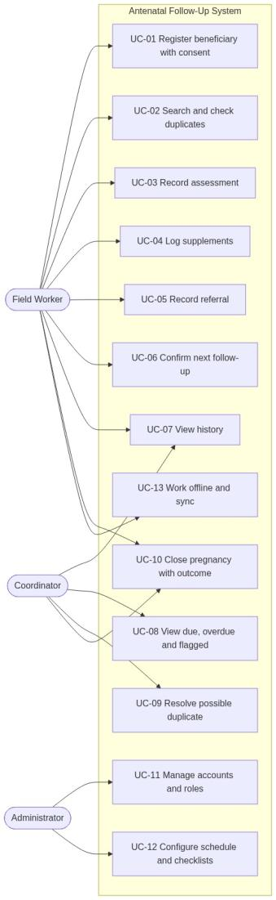  Figure 2: Use case diagram | UC-01 Register beneficiary with informed consent. Precondition: the worker is signed in and the woman agrees to take part. Main flow: (1) the worker reads the local-language consent script; (2) the woman consents and the worker records consent type, date and witness; (3) the worker enters name, age, village, phone, EDD and gravida/parity; (4) the app runs a local duplicate search; (5) the worker confirms, and the record is saved locally and queued for sync. If consent is refused, registration stops and nothing is saved. If a possible duplicate is found, the worker opens the existing profile or confirms a distinct identity with an explanation.  UC-02 Search beneficiary and detect duplicates. Field Worker or Coordinator enters a partial name, village or phone number. The app searches the local IndexedDB cache and, if online, the server using phonetically normalised tokens. Ranked candidates are returned with their pregnancy status.  UC-03 Record antenatal assessment. Precondition: the woman is registered with an active pregnancy and the worker is present. Main flow: (1) open the profile; (2) select ‘New Assessment’; (3) record visit date, gestational age, weight, BP and haemoglobin; (4) tick observed danger signs; (5) log supplements given; (6) record a referral if warning signs are present; (7) confirm the next check-up date; (8) the system validates the entry, saves an immutable assessment and updates the follow-up task. If a critical danger sign is ticked, a prominent ‘Urgent Facility Referral’ banner tells the worker to arrange emergency transport. Section 8 walks through this flow in detail.  UC-04 to UC-08 (supporting).  - UC-04 Log supplements: type and quantity given (IFA, calcium, deworming) with the next refill date.  - UC-05 Record referral: facility, clinical reason, urgent flag and whether transport was arranged.  - UC-06 Confirm next follow-up: accept or change the calculated date, for example around a harvest or festival.  - UC-07 View history: a combined, newest-first timeline of assessments, measurements and referrals.  - UC-08 Monitor due and flagged: the Coordinator filters by ‘Due This Week’, ‘Overdue Follow-Up’ and ‘Flagged Clinical Signs’.

3.3 Role-based access control
Access follows the principle of least privilege: each role receives only the permissions it needs. Roles are checked on the server for every endpoint; hiding a button in the app is never treated as security.
Permission | Field Worker | Coordinator | Administrator
Register beneficiary and record consent | Allowed (assigned village) | Allowed (all NGO villages) | Denied (audit only)
Record assessments and clinical vitals | Allowed (assigned village) | Denied (read-only review) | Denied
Log supplements and referrals | Allowed (assigned village) | Denied (read-only review) | Denied
View village due lists and flagged cases | Allowed (assigned village) | Allowed (all NGO villages) | Denied
Reassign cases and resolve duplicates | Denied | Allowed (supervisory role) | Denied
Manage user accounts, credentials and roles | Denied | Denied | Allowed (full authority)

4. Functional Requirements
Priorities follow the MoSCoW scale: Must, Should, Could. Each requirement names the component that owns it (see Section 6).
ID | Priority | Owner component | Requirement
FR-01 | Must | Auth & Access | Enforce authenticated login and RBAC for Field Worker, Coordinator and Administrator, to protect sensitive records.
FR-02 | Must | Beneficiary Service | Record demographics, village hamlet, consent and EDD as the baseline identity and gestational age for all care.
FR-03 | Must | Beneficiary Service | Check for possible duplicate profiles on the device and on the server using composite matching.
FR-04 | Must | Assessment Service | Record dated assessments with readings and worker identity as immutable records, preserving the clinical audit trail.
FR-05 | Must | Assessment Service | Record observed danger signs and highlight them for coordinator review.
FR-06 | Must | Assessment Service | Log supplements given (IFA, calcium) with dates, types and quantities.
FR-07 | Must | Assessment Service | Record referral details (facility, reason, urgent flag, date) to close the loop on hospital handoffs.
FR-08 | Must | Follow-Up Scheduler | Propose check-up dates from gestational age and let the worker confirm them.
FR-09 | Must | History Service | Show a combined timeline of visits, readings, supplements and referrals that can be reviewed in under 60 seconds.
FR-10 | Must | Beneficiary Service | Provide search by name, village hamlet and phone number, without needing a formal ID.
FR-11 | Must | Sync Service | Store all entries locally when offline and synchronise them through an idempotent batch API.
FR-12 | Must | Follow-Up Scheduler | Provide filtered views of due, overdue and flagged cases so coordinators can target high-risk cases.
FR-13 | Must | Audit Log Service | Record all clinical writes, edits and administrative role changes in an append-only trail.
FR-14 | Should | Beneficiary Service | Allow demographic edits (for example phone or spelling corrections) while preserving assessment history.
FR-15 | Should | Assessment Service | Record delivery outcomes (live birth, stillbirth, loss) and close active follow-ups.
FR-16 | Should | Follow-Up Scheduler | Evaluate follow-up statuses nightly with a scheduled job and flag overdue cases.
FR-17 | Could | Assessment Service | Show subtle indicators when readings fall outside advisor-approved ranges, labelled ‘non-diagnostic’. Disabled until approved (Q-7).
FR-18 | Could | Beneficiary Service | Flag possible duplicate pairs for coordinator review and merge.

5. System Boundary

Inside and outside the system
The boundary separates what the software does from the real-world and medical work that people do. The software records and organises; people examine, decide and act.
Inside the boundary (software) | Outside the boundary (people and medical care)
Beneficiary registration, demographics and consent recording | Verbal conversation, relationship building and ethical explanation of consent
Immutable recording of measurements and observed danger signs | Clinical diagnosis of maternal disease, pre-eclampsia or gestational diabetes
Highlighting recorded risk signs for coordinator attention | Deciding treatments, therapies or drug dosages
Logging supplements distributed by workers (IFA, calcium) | Buying, storing and quality-testing supplements
Recording referral details (facility, reason, date) | Hospital care, triage, ultrasound scans and surgery
Calculating proposed check-up dates from gestational-age rules | Travel, home visits and counselling for families
Showing due, overdue and flagged worklists | Emergency transport, ambulance coordination and crisis response

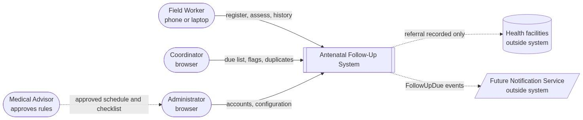
Figure 3: System context diagram

6. Component Architecture

6.1 Architectural principles
Seven principles guide every component decision.
- Offline-first, local-as-master. The client works on local IndexedDB storage. Reads and writes succeed without a network, using client-assigned UUIDs.
- Append-only clinical history. Assessments, supplement logs, referrals and audit entries are dated events and are never overwritten.
- Strict data ownership. Each entity belongs to exactly one module. No module reads another module’s tables; modules communicate through interfaces or events.
- Gatekeeping at the perimeter. The API Gateway (a reverse proxy) handles TLS, throttling and token validation, so every request is authenticated and authorised before business logic runs.
- Idempotent writes. Records use client-generated UUIDv4 identifiers, and each sync operation carries a unique client_op_id and a device_id. The server can therefore detect and skip repeats. (Idempotent means that repeating a request gives the same result and creates no duplicates.)
- Event-driven follow-up work. Saving a visit publishes domain events (for example AssessmentRecordedEvent) that trigger follow-up recalculation asynchronously, so saving does not wait for scheduling.
- Modular monolith first. Phase 1 is one deployable codebase with strict module and schema boundaries, which leaves a clean path to microservices in Phase 2.

6.2 Architecture diagram
Figure 4 shows the system in five layers. The client tier is the Progressive Web App (PWA) with its local store and offline queue. The edge tier is the API Gateway, the only way in. The application services (Sync, Assessment, Auth and Access, Beneficiary, Follow-Up Scheduler, Config and History) hold the business logic. The async backbone is the Event Queue, which carries domain events to the Follow-Up Scheduler, History Service and Audit Log. The data tier holds the primary PostgreSQL database (one schema per service), a read replica, a cache and a separate append-only audit store.
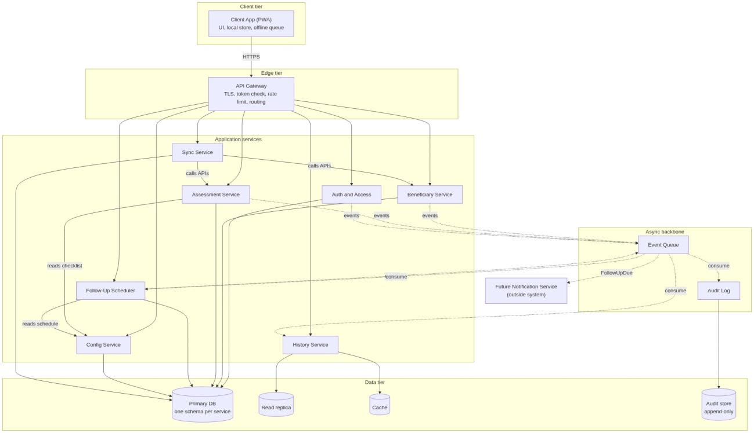
Figure 4: Container diagram - tiers, services and data stores

6.3 Component responsibilities
The system is split into ten components, each with one clear purpose and its own data.
# | Component | Purpose and responsibilities | Data owned | Depends on
1 | Client Application (PWA) | Offline-first interface for field recording, local caching, search and sync-queue management. | Local IndexedDB replica, pending-operation queue, cached user profile. | API Gateway (when online)
2 | API Gateway (reverse proxy) | Single entry point: TLS termination, rate limiting, request validation and routing. | Configuration, route mappings, rate-limit cache. | Auth & Access Control
3 | Auth & Access Control | Verifies credentials, signs and rotates JWTs, enforces RBAC policies. | Hashed credentials, roles, permissions, active sessions. | Relational DB (user store)
4 | Beneficiary Service | Mother profiles, consent records, pregnancy records and duplicate identity checks. | Beneficiary, Consent, Pregnancy. | Database; Event Queue
5 | Assessment Service | Validates and stores assessments, danger-sign flags, supplement logs and referrals. | Assessment, SupplementLog, Referral. | Beneficiary Service; Event Queue
6 | Follow-Up Scheduler | Calculates check-up dates from gestational age and evaluates due and overdue status nightly. | FollowUpTask, visit-schedule configuration. | Assessment Service; Event Queue
7 | History Service | Read-only combined timeline of visits, measurements and referrals. | Read-only timeline views and query indexes. | Beneficiary, Assessment and Follow-Up stores
8 | Sync Service | Processes offline batches with strict idempotency and de-duplication. | SyncReceipt log, client-operation tracking table. | Beneficiary and Assessment Services; Event Queue
9 | Audit Log Service | Immutable, date-ordered record of clinical writes, edits and security events. | AuditEvent append-only ledger. | Relational DB (audit table)
10 | Database & Event Broker | ACID relational storage and the asynchronous internal event bus. | PostgreSQL schemas; Redis event streams / queue. | OS storage and compute

7. Data Flow

7.1 How data moves through the system
Every request follows the same path. Data starts with a user action in the PWA, passes through the API Gateway, is handled by the service that owns that data, is stored in PostgreSQL, and then triggers follow-up work through events:
- User action and client. The worker acts in the PWA. If the device is online, the client sends an HTTPS request. If it is offline, the client saves the operation in the encrypted local queue instead (Section 8.5).
- Gateway and authentication. The API Gateway ends TLS, applies rate limits and checks the JWT and role with Auth & Access Control. Requests that fail are rejected here.
- Business service. The Gateway routes the request to the service that owns the data (Beneficiary, Assessment, History, Follow-Up Scheduler or Sync). The service validates the input and applies its business rules.
- Database. The service writes to its own PostgreSQL schema in a single transaction. Reads of history come from the History Service, which uses a cache and a read replica.
- Response. The service returns the result to the client through the Gateway. The response does not wait for the follow-up processing in step 5.
- Events and follow-up processing. The service publishes domain events. The Follow-Up Scheduler, History Service and Audit Log consume them asynchronously.

Figure 5 shows these paths between the users, the API Gateway, the services, the Event Queue and the data stores. Read it from left to right: users enter through the Gateway, services in the middle do the work, and the Event Queue and stores on the right carry the results onward.
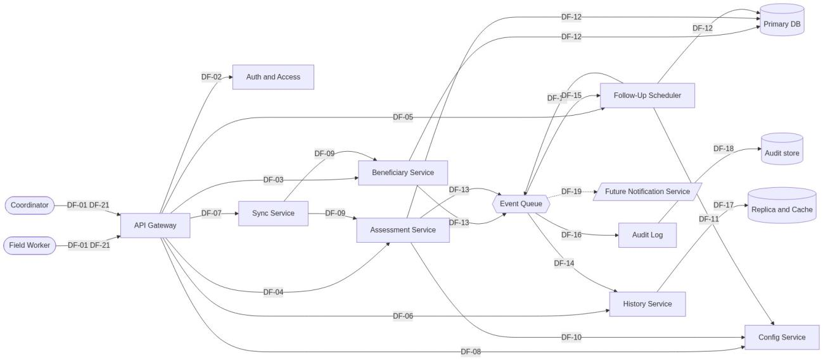
Figure 5: Data flow diagram, level 1
The flows fall into five groups, numbered in the catalogue in Section 7.2:
- Login (DF-01 to DF-03). Credentials go to Auth & Access Control, which returns a signed JWT with the user’s role and organisation (org_id).
- Registration (DF-04 to DF-08). The registration payload with consent and EDD reaches the Beneficiary Service, which stores the beneficiary, consent and pregnancy. A PregnancyCreatedEvent lets the Scheduler create the first proposed follow-up task.
- Assessment (DF-09 to DF-15). The assessment payload reaches the Assessment Service, which checks the pregnancy with the Beneficiary Service and stores the records. Events then update follow-up tasks and the audit log. Section 8 explains this flow step by step.
- History (DF-16 to DF-18). A timeline request is routed to the History Service, which returns events in date order.
- Sync (DF-19 to DF-21). A batch of queued operations goes to the Sync Service, which replays each one and returns a result per operation.

7.2 Data flow catalogue
The table lists each numbered flow with its payload and whether it is synchronous (the caller waits) or asynchronous (carried by an event).
ID | From | To | Payload | Protocol / mode
DF-01 | Client Application | API Gateway | Login credentials (username, password hash) | HTTPS REST (sync)
DF-02 | API Gateway | Auth & Access | Credential verification request | gRPC / internal (sync)
DF-03 | Auth & Access | Client Application | Signed JWT, role permissions, org_id context | HTTPS REST (sync)
DF-04 | Client Application | API Gateway | Registration payload with consent and EDD | HTTPS REST (sync)
DF-05 | API Gateway | Beneficiary Service | Validated registration request with bearer token | Internal API (sync)
DF-06 | Beneficiary Service | Database | Insert into BENEFICIARY, CONSENT, PREGNANCY | PostgreSQL TCP (sync)
DF-07 | Beneficiary Service | Follow-Up Scheduler | PregnancyCreatedEvent (pregnancy_id, EDD, worker_id) | Internal event bus (async)
DF-08 | Follow-Up Scheduler | Database | Insert initial PROPOSED follow-up task | PostgreSQL TCP (sync)
DF-09 | Client Application | API Gateway | Assessment payload (vitals, danger signs, supplements) | HTTPS REST (sync)
DF-10 | API Gateway | Assessment Service | Validated assessment payload with token context | Internal API (sync)
DF-11 | Assessment Service | Beneficiary Service | Verify that pregnancy_id exists and is ACTIVE | Internal API (sync)
DF-12 | Assessment Service | Database | Insert into ASSESSMENT, SUPPLEMENT_LOG, REFERRAL | PostgreSQL TCP (sync)
DF-13 | Assessment Service | Follow-Up Scheduler | AssessmentRecordedEvent (pregnancy_id, date, danger_signs) | Internal event bus (async)
DF-14 | Assessment Service | Audit Log Service | AuditEvent (worker_id, assessment_id, timestamp) | Internal event bus (async)
DF-15 | Follow-Up Scheduler | Database | Mark current task COMPLETED; insert next PROPOSED task | PostgreSQL TCP (sync)
DF-16 | Client Application | API Gateway | Beneficiary timeline history request | HTTPS REST (sync)
DF-17 | API Gateway | History Service | Route history lookup by beneficiary_id | Internal API (sync)
DF-18 | History Service | Client Application | Chronological array of historical events | HTTPS REST (sync)
DF-19 | Client Application | API Gateway | Offline sync batch of queued operations | HTTPS REST (sync)
DF-20 | API Gateway | Sync Service | Sync batch with client_op_id list | Internal API (sync)
DF-21 | Sync Service | Client Application | SyncBatchReceipt (per-operation result) | HTTPS REST (sync)

7.3 Domain events
Four domain events are published to the message broker. They let one module trigger work in another without calling it directly.
- PregnancyCreatedEvent - from the Beneficiary Service on enrolment. The Follow-Up Scheduler creates the first check-up milestone.
- AssessmentRecordedEvent - from the Assessment Service when a visit is saved. The Follow-Up Scheduler closes the current task and computes the next one, the History Service refreshes its cache, and the Audit Log records the write.
- RiskSignFlaggedEvent - from the Assessment Service when danger signs are marked. The Follow-Up Scheduler raises priority and the interface shows supervisory alert badges.
- PregnancyClosedEvent - from the Beneficiary Service on delivery or loss. The Follow-Up Scheduler cancels all pending tasks.

8. Detailed User Flow: Record an Antenatal Assessment

8.1 Scenario and starting conditions
The Field Worker visits Lakshmi, who has an ACTIVE pregnancy and recorded consent. The worker is signed in and may have limited network connectivity.
Data entered: BP 135/88 mmHg, weight 58 kg, severe headache, 30 IFA tablets given, and a CHC referral.
Outcome: The system saves the assessment, supplement log, and referral; updates the follow-up task and history; records an audit entry; and confirms success. Flagged cases appear in the Coordinator’s list (UC-08).

8.2 The Flow at a Glance
Figure 6 shows the flow from left to right across the components, and from top to bottom in time. Steps 1-10 find the woman and show her history. Steps 11-28 record the assessment while the device is online, and the last block shows what happens when the device is offline.

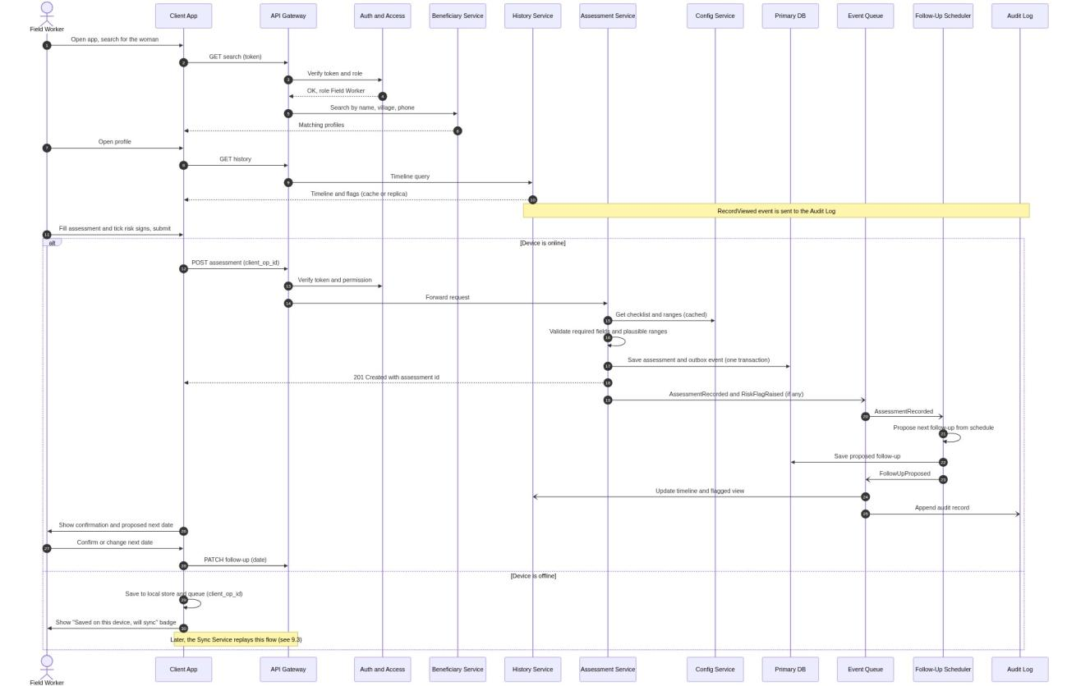

Figure 6: Sequence diagram - record an antenatal assessment

8.3 Step-by-step explanation
Each step names where the data originates, which component handles it, and what is stored or updated. Steps A1-A2 correspond to the first part of Figure 6, B1 to the form entry, C1-C7 to the online path, and D1 to the offline path.
Step | What happens | Components | Data stored or updated
A. Find the woman and review her history
A1 | The worker opens the app and searches by name, village or phone. The client sends the search with the JWT. The Gateway asks Auth & Access to verify the token and role. The Beneficiary Service searches and returns matching profiles. Offline, the same search runs on the local IndexedDB cache. | Client App, API Gateway, Auth & Access, Beneficiary Service | Nothing is stored. Data is read from the Beneficiary store.
A2 | The worker opens Lakshmi’s profile. The client requests her history. The Gateway routes the request to the History Service, which returns the timeline and flags from its cache or read replica. A RecordViewed event is sent to the Audit Log. | Client App, API Gateway, History Service, Audit Log | An audit entry is appended. No clinical data changes.
B. Enter the assessment
B1 | The worker completes the assessment form: visit date, gestational age, weight, BP, haemoglobin if measured, danger signs, supplements and referral. The client checks values against plausible ranges, blocks impossible values (EC-09) and creates an assessment_id (UUIDv4) and a client_op_id. A draft is saved locally at each wizard step (EC-04). | Client App | Local draft in IndexedDB only.
C. Online path
C1 | The client sends POST /api/v1/assessments with the client_op_id as the Idempotency-Key. The Gateway verifies the token and permission with Auth & Access and forwards the request to the Assessment Service. | Client App, API Gateway, Auth & Access | Nothing is stored.
C2 | The Assessment Service gets the approved checklist and ranges from the Config Service (cached) and validates required fields and plausible ranges. It confirms with the Beneficiary Service that the pregnancy exists and is ACTIVE (DF-11). If validation fails, it returns an error and nothing is saved. | Assessment Service, Config Service, Beneficiary Service | Nothing is stored.
C3 | In one database transaction, the Assessment Service saves the assessment, the supplement log and the referral, together with an outbox event. has_flagged_risk is set to TRUE because a danger sign is ticked. | Assessment Service, PostgreSQL | New rows in ASSESSMENT, SUPPLEMENT_LOG and REFERRAL (append-only).
C4 | The service returns 201 Created with the assessment_id. The worker’s screen shows that the visit is saved. | Assessment Service, API Gateway, Client App | Nothing further.
C5 | AssessmentRecordedEvent, and RiskSignFlaggedEvent where danger signs were ticked, are published to the Event Queue. If the broker is down, the outbox table holds them until they can be sent. | Assessment Service, Event Queue | Events queued.
C6 | The Follow-Up Scheduler consumes the event, marks the current task COMPLETED, proposes the next follow-up from the visit schedule and saves it as PROPOSED. A flagged assessment raises the task’s priority. The History Service refreshes the timeline and flagged view. The Audit Log appends an audit record. | Follow-Up Scheduler, History Service, Audit Log, PostgreSQL | FOLLOW_UP_TASK updated and inserted; timeline cache refreshed; AuditEvent appended.
C7 | The app shows the confirmation and the proposed next date. The worker confirms or changes it (UC-06), and the client sends a PATCH for the follow-up date. The task becomes CONFIRMED. | Client App, API Gateway, Follow-Up Scheduler | FOLLOW_UP_TASK confirmed_date set.
D. Offline path
D1 | If the device is offline at the end of B1, the client saves the assessment in the encrypted local store and queue with its client_op_id, protected by an HMAC hash, and shows a ‘Saved on this device, will sync’ badge. When the network returns, the Sync Service replays the operation through the same services (Section 8.5). | Client App, later Sync Service | Queued operation in IndexedDB until synced.

Two points about this flow are worth noting. First, the assessment is written once and never changed: a later visit adds a new record. Second, scheduling, history and audit work happen after the response, so a slow Scheduler never delays the worker.

8.4 Registration with duplicate check
Registration is the other important write flow. It runs a two-stage duplicate check, first on the device and then on the server, using phonetic matching so that spelling variations (for example ‘Lakshmi Devi’ and ‘Lakshmi D.’) are still compared.
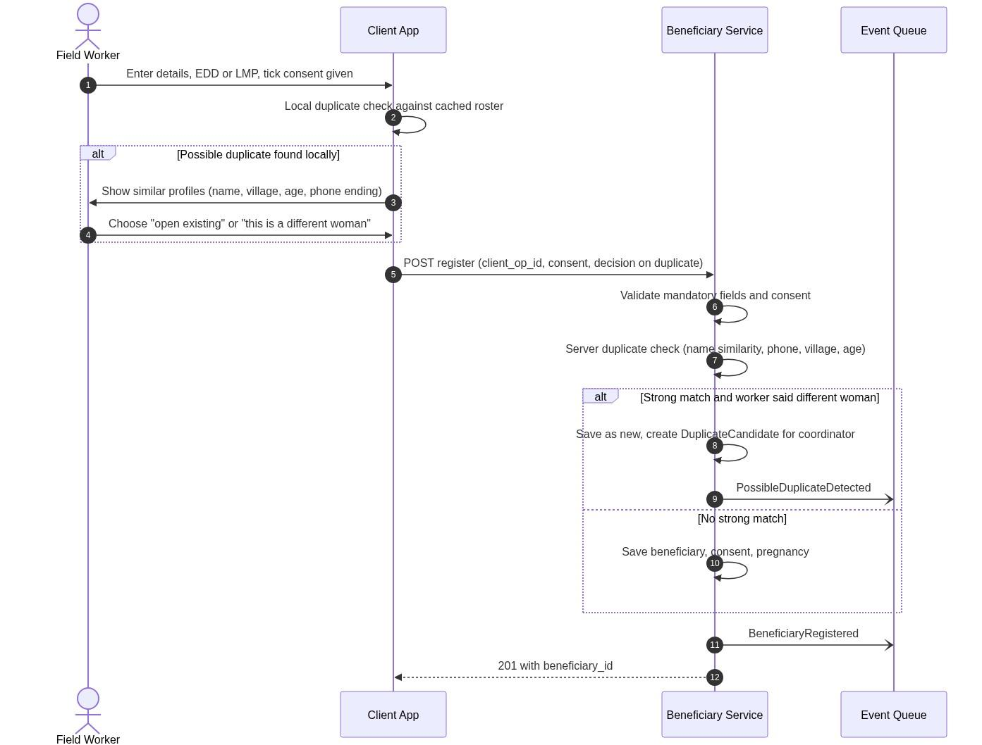
Figure 7: Sequence diagram - registration with duplicate check
- The worker enters the details and EDD (or LMP) and ticks that consent was given. If consent is refused, nothing is saved (EC-01).
- The client searches its cached roster for similar profiles. If any are found, it shows them (name, village, age, phone ending) and the worker either opens the existing profile or states that this is a different woman.
- The client sends the registration (client_op_id, consent, and the worker’s decision on the duplicate) to the Beneficiary Service.
- The service validates the mandatory fields and consent, then runs its own duplicate check on name similarity, phone, village and age.
- If there is a strong match but the worker said this is a different woman, the service saves the new record, creates a DuplicateCandidate for the Coordinator and publishes PossibleDuplicateDetected. Otherwise it saves the beneficiary, consent and pregnancy.
- The service publishes BeneficiaryRegistered and the PregnancyCreatedEvent that starts the first follow-up task (DF-07, DF-08), and returns 201 Created with the beneficiary_id.
When two workers register the same woman offline in nearby hamlets, the server finds the match during sync, keeps both records and alerts the Coordinator to review and merge them (EC-05, UC-09).

8.5 Offline entry and batch synchronisation
In network dead zones, every write goes into an encrypted local queue and each queued operation has its own client_op_id. When the network returns, the client uploads the queue as one batch (Figure 8). The Sync Service processes the operations in order. If it has already seen a client_op_id, it returns the stored result and writes nothing again. If the operation is new, it passes it to the Beneficiary or Assessment Service and stores a SyncReceipt. The client then receives a result for each operation: OK, DUPLICATE_OP, CONFLICT or REJECTED with a reason. It removes the OK items and keeps CONFLICT and REJECTED items visible to the worker.
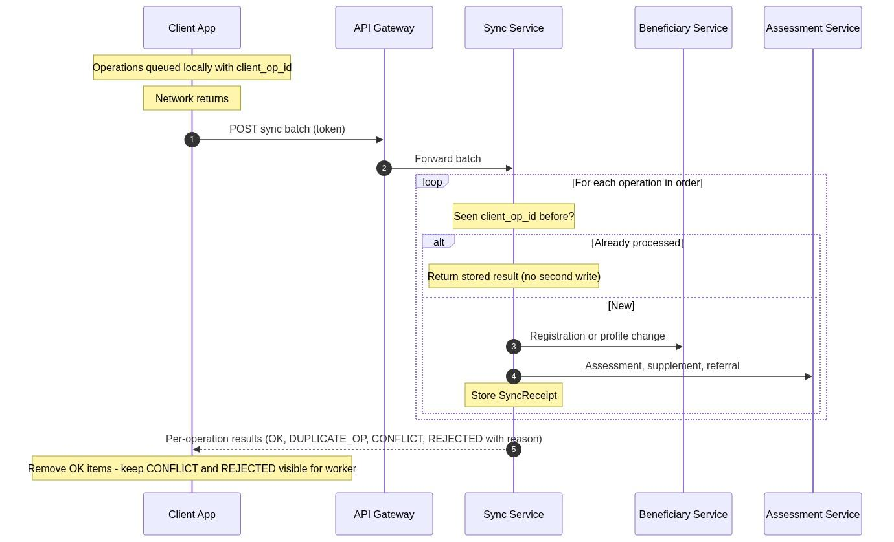
Figure 8: Sequence diagram - offline entry and synchronisation
If two offline workers send conflicting updates for the same beneficiary, the later update by verified UTC timestamp wins (last-write-wins) and both versions are kept in the audit trail (EC-11).

8.6 Nightly Follow-Up Evaluation
Every night at 02:00 UTC a background job scans active pregnancies, computes gestational progress and moves follow-up tasks from Confirmed to Due or Ovrdue (Figure 9).

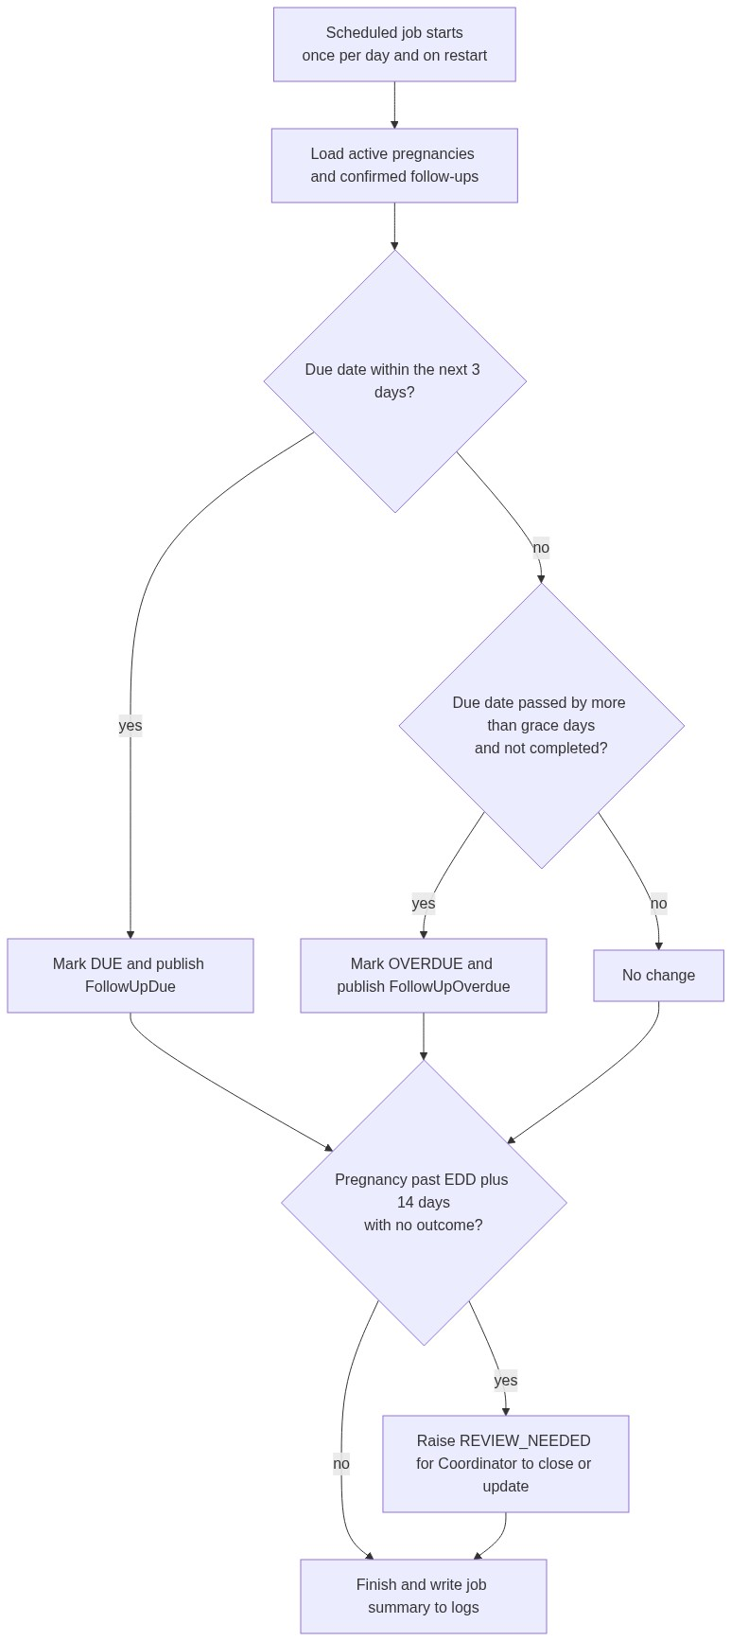  Figure 9: Nightly follow-up evaluation | 8.7 System State Transition Models  Two finite state machines govern the lifecycles of beneficiaries and follow-ups. Beneficiary: Registered → Active (during pregnancy) → Closed (delivery, loss or transfer) (Figure 10).  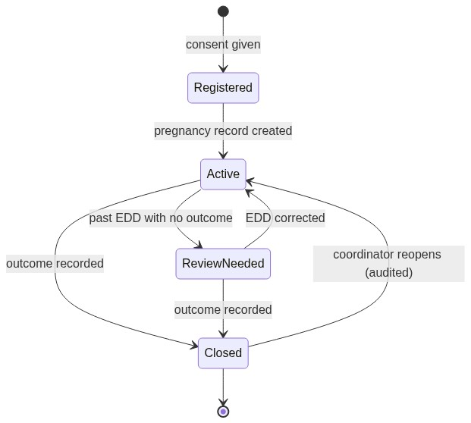  Figure 10: Beneficiary lifecycle  Follow-up task: Proposed → Confirmed → Due → Overdue → Completed / Cancelled (Figure 11).  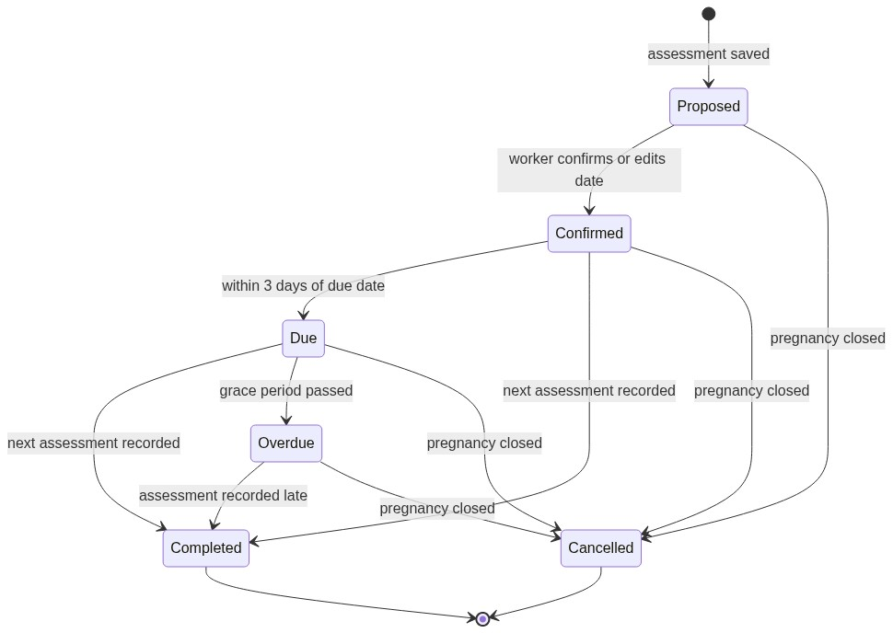  Figure 11: Follow-up task state model

9. Limitations

9.1 Limitations of the current design
These are limits of the proposed design as documented. They are not planned features, and none of them is addressed by a component in this document.
- No immediate emergency alert. When a field worker identifies an emergency case, the design provides no way to alert the relevant worker or facility from within the system. The app shows an urgent referral banner on the worker’s own screen, and the worker follows the NGO’s verbal emergency protocol outside the app (Q-6). The system does not send notifications to anyone.
- Status can lag by up to a day. Due and overdue statuses change only in the nightly evaluation (DD-06).
- Offline data is not visible until synced. Records captured offline reach Coordinators and other workers only after the device syncs (RSK-01). Concurrent offline edits to the same beneficiary are resolved by last-write-wins (EC-11).
- Duplicate detection is probabilistic. Phonetic matching can miss or wrongly suggest matches, so a Coordinator may need to review and merge profiles (RSK-02).
- Clinical dates are estimates. LMP and EDD are often approximate, so gestational age and proposed dates may be approximate (C-6).
- Referral outcomes depend on manual entry. Without hospital integration, the system knows only what workers record about a referral (A-7).
- Browser storage limits. A PWA has tighter storage quotas than a native app (DD-02).
- Phase 1 scales as one unit. All modules share one container and one database, so they scale together (DD-01).

9.2 Deferred items and future dependencies
The items below are deliberately excluded from this release. Each has an interim position and a note on what a later phase would need.
Item | Position in this release | Needed for a later phase
Newborn tracking after delivery | The pregnancy is closed with a structured delivery outcome (Q-1). | A Phase 2 paediatric module.
Beneficiary view or edit of her own file | Not provided, to protect privacy on shared village devices. Workers make audited corrections on request (Q-5). | A decision on beneficiary credentials and access.
Direct hospital integration | Referrals happen outside the system; only referral details are recorded (A-7). | FHIR/HL7 interfaces and two-way intake APIs.
Automated SMS to beneficiaries | Excluded because of feature phones, shared devices and domestic privacy concerns (Section 5.2). | Not planned; outside the system boundary.
SMS/USSD fallback for legacy phones | Workers are assumed to use Android 9+ devices with modern browsers (A-8). | SMS/USSD fallback alongside the PWA.
Cross-NGO identity linking | Each NGO tenant is isolated (C-7, A-3). | A secure identity exchange and federated tenant privacy framework.
Scaled-out multi-tenant deployment | Phase 1 modular monolith for 5–50 workers (A-10, DD-01). | Independent services, load balancer and distributed queue (Figure 14).
Out-of-range reading indicators | Visual highlighting only, labelled for coordinator review; disabled until the medical advisor signs off (Q-7, FR-17). | Advisor approval of ranges (Appendix A values are defaults).

10. Self-Review

Review against the assignment questions
- Does every component have a clear reason to exist? Yes. Section 6.3 gives each component one responsibility, and none is redundant.
- Are responsibilities separated rather than mixed? Yes. The Beneficiary Service manages identity but knows nothing about blood pressure. The Assessment Service records visits but does not compute scheduling. The Scheduler computes schedules but never stores vitals. No two components own the same tables.
- Can the boundaries be explained? Yes. The system records observations, schedules check-ups and flags risk signs for review. It does not diagnose, prescribe, send SMS to mothers or connect to hospital systems (Section 5).
- Could another person understand the design without a verbal explanation? The document provides 14 figures, entity schemas, a 21-flow data catalogue, a step-by-step walkthrough, API contracts, edge cases and a glossary.

